GROUP 9 PROJECT DOCUMENTATION

Table of Contents
Group members 3
Tasks: 4
Database Design and Setup 4
Report on task 1: 4
Java Application Development 7
Report on task 2 7
Statistical Analysis 7
Report on task 3 8
Challenges 12

Group members
1.Tecla Gatwiri 222203
2. Daniella Awuor 222202
3.Mumtaz Yussuf 220386
4. Sylvia Waithira Muigai 181038
5. Chelsea Lorna 220734

Tasks:

Database Design and Setup
- Study the dataset assigned to your group (2–4 CSV files).
- Design an ER diagram to capture entities and relationships.
- Create relational tables in SQL with correct data types, primary keys, and foreign keys.
- Import the CSV data into the database.

Report on task 1:

Screenshots
CODE
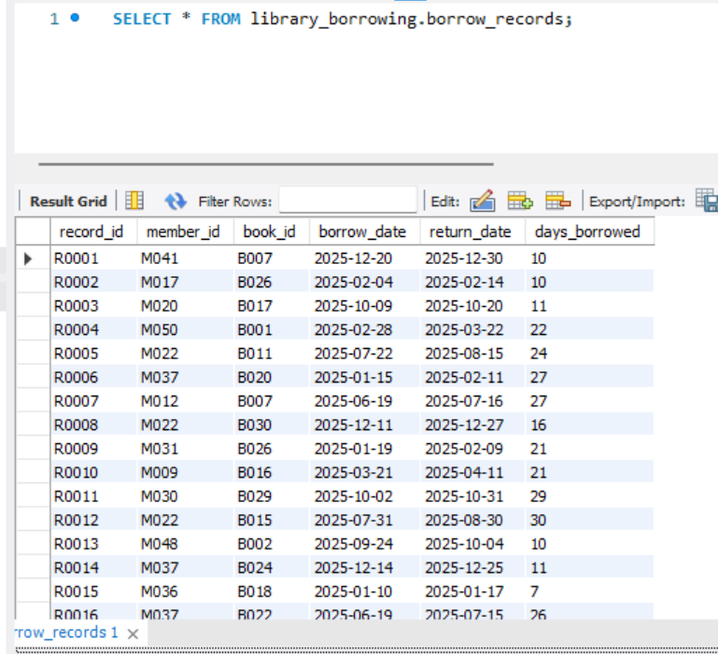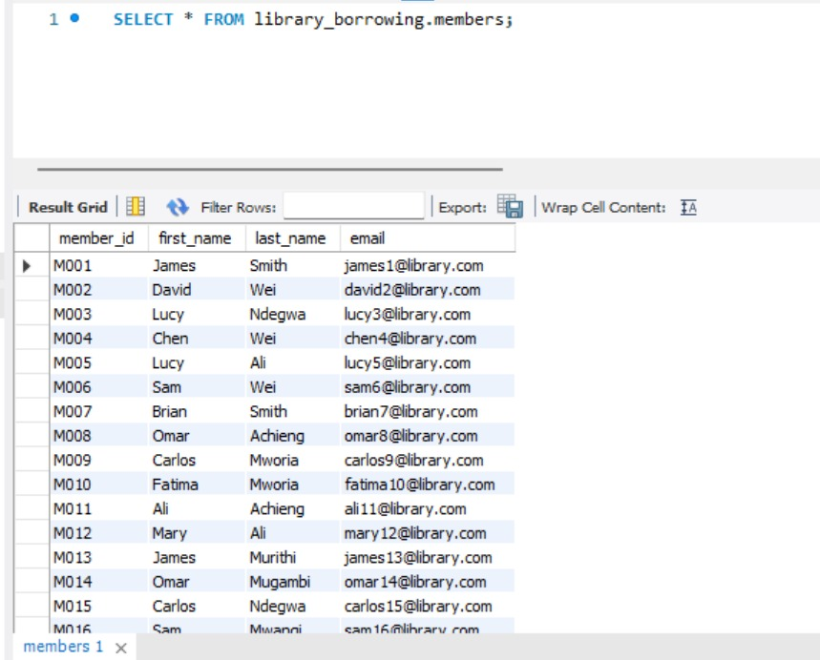
ER Diagram
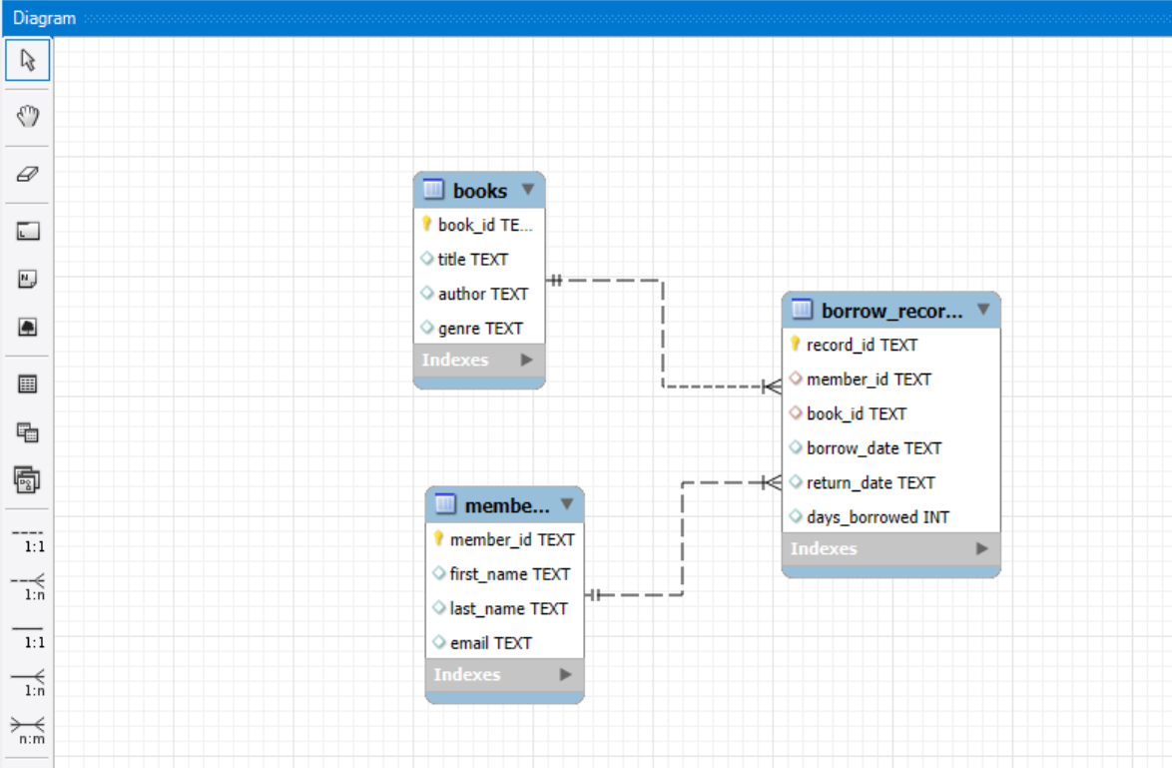

Findings
We find out that the SELECT is the SQL command used to retrieve data from a database.
The asterisk is a wildcard that means “all columns."
So this part of the command is saying, “Retrieve every column from the table.”
FROM is a clause that specifies which table to get the data from.
library_borrowing.members: This is the full table name, which has two parts:
- library_borrowing: This is likely the database name or schema name
- members: This is the actual table name that contains the member data
We can therefore conclude that the entire statement
SELECT * FROM library_borrowing.members;
Shows all columns and all rows from the members table in the library_borrowing database.
From the ER diagram we can conclude that it features three main tables:
- books: Stores information about the books in the library.
Primary Key : book_id
Attributes: title , author , genre
- members: Stores information about the library's members.
Primary Key : member_id
Attributes: first_name , last_name, email .
- borrow_records: A junction table that records each instance of a book being borrowed.
Primary Key : record_id
Foreign Keys : member_id (referencing members), book_id (referencing books).
Attributes: borrow_date , return_date , days_borrowed .
The diagram uses to show the relationships:
Relationship | Entities | Type | Meaning
Member to Borrow Record | members and borrow_records | One-to-Many (1:N) | A single member can have multiple borrow records, but each borrow record belongs to exactly one member.
Book to Borrow Record | books and borrow_records | One-to-Many (1:N) | A single book can appear in multiple borrow records (i.e., be borrowed multiple times), but each borrow record is for only one book.
Implicit Member to Book | members and books | Many-to-Many (N:M) | A member can borrow many books, and a book can be borrowed by many members. This relationship is resolved by the borrow_records junction table.

Java Application Development
Write a java program to:
- Upload the CSV files into the database (optional if you imported via SQL first).
- Establish a database connection using JDBC.
- Run queries to extract and aggregate data.
- Generate and display statistical results.
- Produce charts and graphs (e.g., bar charts, line charts, pie charts).

Report on task 2

In this section, I present the visualization outputs generated by the Java application I developed. These charts were produced using the *JFreeChart* library, based on data retrieved from the MySQL database (data_analysis_db). The charts provide an intuitive visual interpretation of the library’s operational data.
The system generates three main types of charts:
1. Bar Chart — Comparative Summary of Library Entities
2. Pie Chart — Distribution of Borrow Frequency
3. Line Chart — Monthly Borrow Trend

Charts and graphs
Bar chart
Purpose:

To provide a high-level comparison of the main entities in the library database:
- Number of books
- Number of members
- Number of borrow records
This gives a fast, visual understanding of the scale of library operations.
How It Was Generated:
The bar chart pulls three values from the database using the DataAnalyzer class:
getTotalBooks()
getTotalMembers()
getTotalBorrowRecords()
The values are inserted into a DefaultCategoryDataset.
JFreeChart’s createBarChart() method generates the visualization.
A Swing JFrame displays the chart.
Interpretation
Books: Indicates the size of the library’s collection.
Members: Reflects the number of registered library users.
Borrow Record: Shows user engagement with the library.

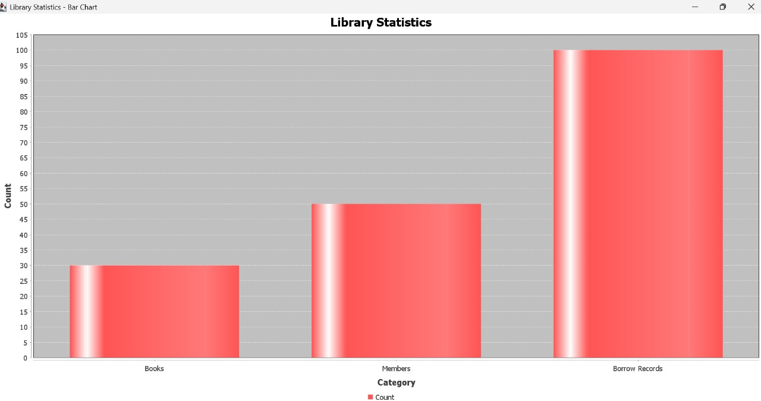
A large gap between “books” and “borrow records” suggests lower borrowing activity relative to collection size, while a high borrow count compared to members indicates active usage.

Pie Chart
Purpose:
To highlight which book is the most borrowed and compare it against all other books.
How It Was Generated:
The DataAnalyzer.getMostBorrowedBook() method identifies the top book using an SQL GROUP BY + COUNT(*) query.
The borrow count of the top book is extracted from the returned string.
A pie chart dataset is created:
Slice 1: Borrow count of the most borrowed book
Slice 2: Total remaining borrow records
JFreeChart’s createPieChart() generates the visualization.
Interpretation
The chart illustrates how dominant the top-performing book is.
A large slice for "Other Books" suggests borrowing is spread across multiple titles.
A large slice for the most borrowed book means one book is significantly more popular.
This visualization is key for understanding user preferences and library resource demand.
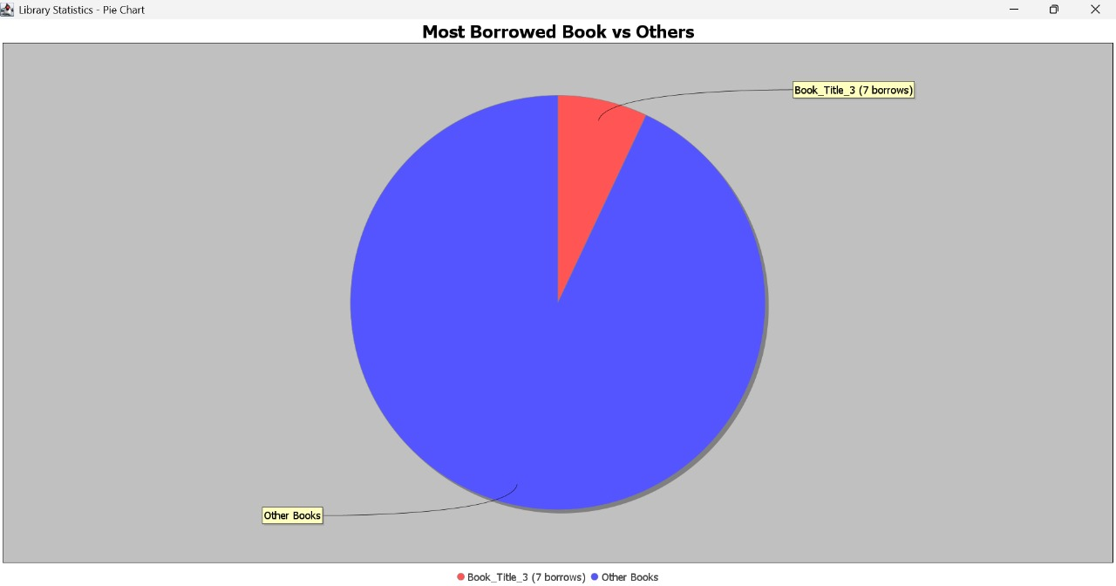
Line chart
Purpose
To analyze changes in borrowing activity over time, showing trends across months.
How It Was Generated

DataAnalyzer.getMonthlyBorrowTrend() runs a SQL query that groups borrow records by month.
Results are added into a DefaultCategoryDataset.
JFreeChart’s createLineChart() function generates the trend visualization.
Interpretation
A rising line indicates increasing borrowing activity in certain months.
A falling line suggests seasonal declines or inactive periods.
This chart allows the library to see peak months and low-traffic periods.
The visualization component significantly enhances the interpretability of the raw data and transforms it into meaningful insights for strategic planning.

Statistical Analysis
Each group must complete the core analysis tasks listed in your group’s README file .
These are the tasks our group was assigned:
- Identify the most borrowed books.
- Identify the most active members.
- Calculate average borrowing duration and overdue counts.
- Determine genre popularity distribution.
- Create visualizations (bar chart, pie chart, histogram).

Report on task 3

Queries, interpretation and visualization.
SQL Queries Used and interpretations
  - Most Borrowed Books
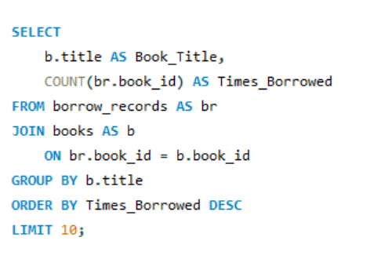
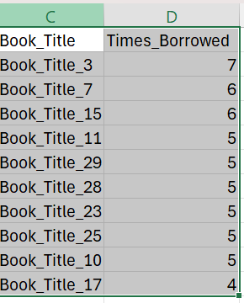

Interpretation
The query counts how many times each book was borrowed and lists the top 10.
Book tittle 3 was the most borrowed book indicating stronger user interest in it.
b. Most Active Members
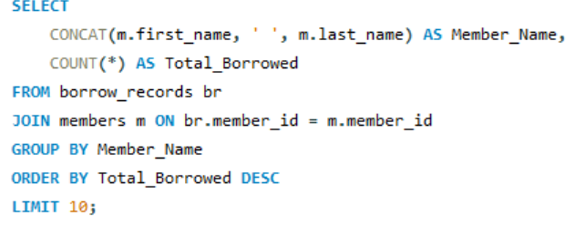
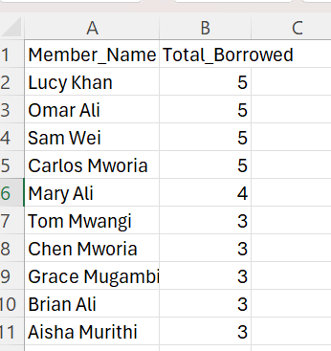
Interpretation
This query identifies members who borrowed the most books with the highest having borrowed five books.
It suggests that the members are frequently library users.

c)Average Borrowing Duration and Overdues
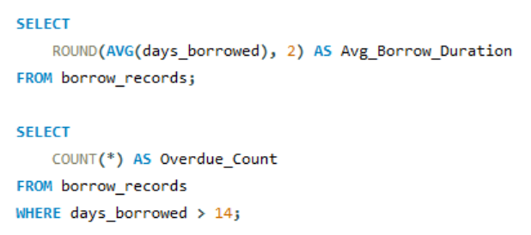
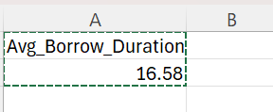
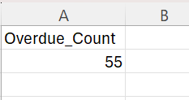

Interpretation
The above queries produced results that the average borrowing duration is approximately 16.58 days with 55 overdue records,whereby the borrowing duration was set at a maximum of 14 days.

d. Genre Popularity
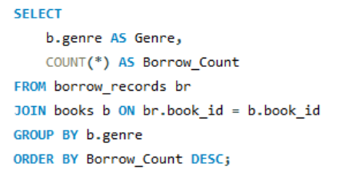
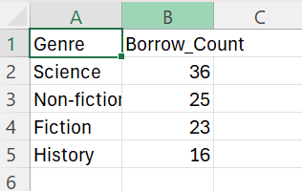
Interpretation
From the analysis,Science genre books were borrowed most.

e)Visualizations

Challenges
We experienced a challenge in collaborating using GitHub and learning how to use MYSQL but after team work and research we were able to work our way out.
Github link : https://github.com/mumtaz-data/DataAnalysisApp

